Phase 2 - Prioritising Needs
Case study: Legacy-Trust Bank.

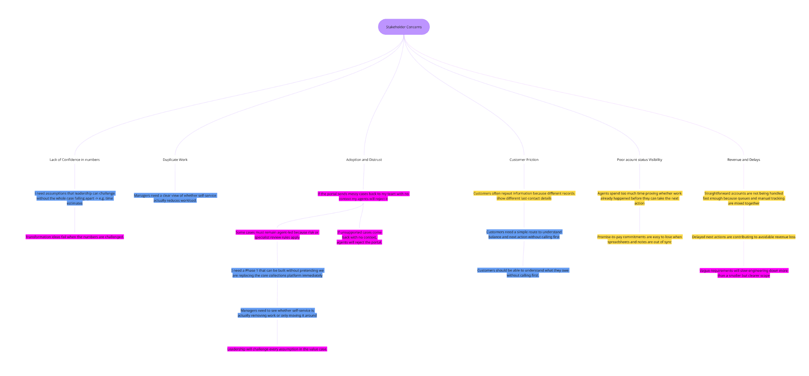
Stakeholder evidence

Stakeholder | Quote or observation | Theme | Business impact | Confidence
Amina Rahman | Agents spend too much time proving whether work already happened. | Operational Inefficiency | Cost and efficiency drain. | High
Daniel Okoye | Delayed next actions are contributing to avoidable revenue loss. | Revenue and delays | Direct revenue leakage. | Medium
Gareth Evans | If the portal sends messy messages my agents will reject it. | Adoption and distrust | Total adoption risk | High
Collections agents | Customers often repeat information because records show different details. | Customer friction | Brand friction and CX | Medium
Compliance Liaison | Some cases must remain agent-led because risk/ specialist rules apply. | Adoption and distrust | Regulatory/ risk control | High

JTBD-01. When I have an outstanding balance, I want to know how much I owe without having to call first so that I can settle my debt independently and with confidence.
JTBD-02. When providing my personal details, I want to ensure my identity is recognised accurately so that I can complete my setup without repetitive manual effort.
JTBD-03. When I have a case to work on, I want to distinguish between settled and active accounts at a glance so that I can focus my energy only on the cases that require my expertise.
JTBD-04. When presenting a proposal to leadership, I want the assumption to be solid and stable so that the whole case doesn’t fall apart.
JTBD-05. When a customer uses the self-service, I want to know if work is being removed for my agents so that I can prove my team is focused on the most critical customer problems.
JTBD-06. When a case is being handled in the portal, I want to know it contains all necessary context and isn't “messy” so that my agents don’t reject it and can focus on resolving customer issues.
JTBD-07. When assessing recovery costs, I want to eliminate manual intervention for straightforward cases so that delays are reduced and the recovery process stops leaking value.
JTBD-08. When I am assessing financial performance gaps across the bank, I want to be certain that our baseline operations are legally compliant and cost-optimised by default, so that I can focus entirely on identifying the root causes of revenue loss.

JTBD ID | Actor | Statement | Evidence link | Portal relevance | Priority
JTBD-01 | Customer | When I have an outstanding balance, I want to know how much I owe without having to call first so that I can settle my debt independently and with confidence. | Low (2)  Customers should be able to understand what they owe without calling first. | Medium | Medium
JTBD-02 | Customer | When providing my personal details, I want to ensure my identity is recognised accurately so that I can complete my setup without repetitive manual effort. | High (5)  Need a route which avoids customers repeating information because different records show different last-contact details.  Managers need a clear view of whether self-service actually reduces workload. | Low | Medium
JTBD-03 | Agent | When I have a case to work on, I want to distinguish between settled and active accounts at a glance so that I can focus my energy only on the cases that require my expertise. | High (7)  Agents spend too much time proving whether work already happened before they can act. | Low | High
JTBD-04 | Agent | When presenting a proposal to leadership, I want the assumption to be solid and stable so that the whole case doesn’t fall apart. | Medium (4)  Leadership will challenge every assumption in the value case. | Low | Medium
JTBD-05 | Operations manager | When a customer uses the self-service, I want to know if work is being removed for my agents so that I can prove my team is focused on the most critical customer problems. | High (5)  Managers need a clear view of whether self-service actually reduces workload. | High | High
JTBD-06 | Operations manager | When a case is being handled in the portal, I want to know it contains all necessary context and isn't “messy” so that my agents don’t reject it and can focus on resolving customer issues. | High (6)  If unsupported cases come back with no context, agents will reject the portal. | High | High
JTBD-07 | Finance partner | When assessing recovery costs, I want to eliminate manual intervention for straightforward cases so that delays are reduced and the recovery process stops leaking value. | High (6)  Straightforward cases are delayed because manual queues and trackers do not agree.  The manual recovery process is leaking value. | Medium | High

JTBD-06 - Currently, untracked, unsynched data is causing delays in which the agents handle cases subsequently being a major contributor to the 15% revenue leak through delayed follow-ups, so if this isn’t tackled during the portal implementation then the situation will only get worse. High frequency (5/6 stakeholders) reported that adoption risk was one of their main concerns. To incorporate this into Phase 1 Scope, the portal must enforce Data Integrity at Entry. If the data isn't complete, the "Submit" button stays grey. This eliminates the "messy" cases and cases which lack context from the start.
JTBD-03 - Agents are wasting their time opening accounts that are already settled and this is also contributing to the 15% revenue leak through delayed actions, so if this isn’t tackled immediately then as the number of cases accumulate revenue loss will increase and delayed responses/ follow-ups to customers will increase. High frequency (6/7 stakeholders) observed using local workarounds, email templates and spreadsheet trackers) to track case status on top of the legacy collections database. This can influence Phase 1 scope by the implementation of High-Visibility Status Badges in the portal list view. This allows agents to "filter by urgency" immediately. Phase 1 could also implement a Single Source of Truth (SSoT), which will eliminate redundant data reconciliation and ensure all stakeholders act on the same real-time information.
JTBD-05 - Currently, the lack of visibility into "work-removed" makes it impossible to validate the ROI of automation, meaning resources remain locked in low-value tasks while high-yield recovery stalls. This lack of data is a major hurdle for the value case; if we cannot quantify self-service deflection, we cannot prove the portal is actually plugging the revenue leak. High frequency (5 stakeholders) identified that managers need a clear view of whether self-service actually reduces workload as a primary concern. To influence Phase 1 Scope, the portal can include Real-time Deflection Analytics and Volume Attribution Dashboards. This will allow management to track exactly which cases are successfully offloaded from agents, providing the solid and stable evidence needed to defend the investment to leadership.

